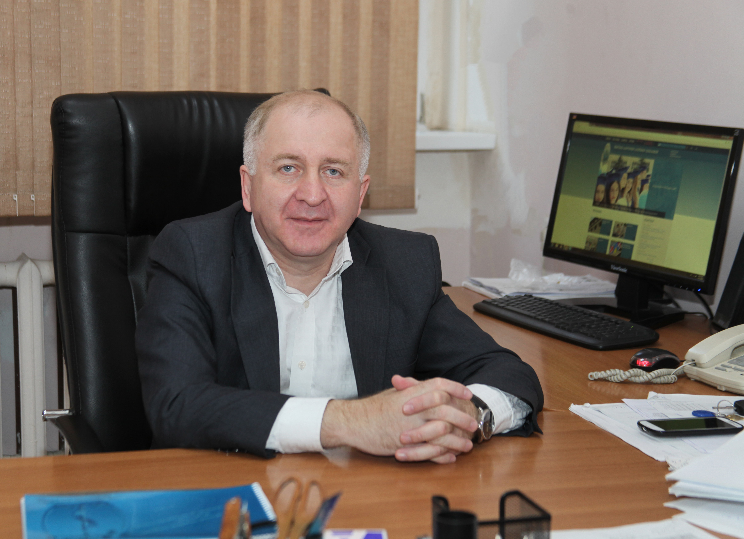
CV
NMamuka Kalmakhelidze

Date of Birth: 24.11.1964
ID: 01019016600
Address: 27, Svaneti str. Tbilisi, Georgia
Tel: (+995 32) 254 24 34
Mob: (+995 77) 90 71 71
Email: mamuka.kalmakhelidze@gmail.com
Marital status: a spouse and 3 children

Education

1971 – 1982 | 112 Secondary School, Tbilisi
1983 – 1988 | Georgian Technical University; Faculty of Mechanical Engineering; Specialty: Engineer-Mechanic;
1993 – 1995 | I. Javakhishvili Tbilisi State University; Faculty of F inances and Credit; Specialty - Economist;
2000–2006 | Georgian Academy of Customs Affairs, Faculty - Customs Affairs; Specialty - Economist;

Working Experience

19.09.1988 – 09.06.1992 | Factory of Computing (Electric Calculating)Technique, Tbilisi; Engineer-Technologist;
10.06.1992 – 17.11.1994 | Chamber of Control of Georgia (CCG). Chief Inspector of Rustavi Chamber of Control;
17.11.1994 – 11.05.1995 | Managing inspector of Kvemo-Kartli Region
11. 05.1995 – 11.12.1995 | Head of the Chamber of Control of Kvemo-Kartli Region
11.12.1995 – 15.12.1999 | Deputy Head of the Chamber of Control of Kvemo-Kartli Region
15.12. 1999 – 23.10.2000 | Georgia State Tax Department;  Head of Gardabani Tax Inspection;
23.10.2000 – 14.10.2001 | Head of Tax Inspection of Tbilisi Didube-Chugureti District;
26.11.2001 – 11.04.2002 | Managing Inspector of the Western Georgia Tax Payment Department of Tax Inspection Division for Large-Scale Taxpayers
11.04.2002 – 29.08.2002 | Head of the Eastern Georgia Tax Payment Department of Tax Inspection Division for Large-Scale Taxpayers
29.08.2002 – 01.10.2004 | Head of Gardabani Zonal /Regional Tax Inspection of Tax Department of the Ministry of Finance of Georgia;
01.10.2004 – 14.07.2005 | Head of Tax Audit (Check-ups) Division of Inspection Taxpayers of Rustavi Tax Department
14.07.2005 – 10.03.2006 | Head of Tax Audit (Check-ups) Division of Inspection Taxpayers of Tbilisi
10.03.2006 – 14.11.2006 | Deputy Head of Tbilisi Tax Inspection;
14.11.2006 – 25.12.2006 | Head of Kakheti Regional Tax Inspection of Tax Department;
17.01.2008. – till present | LTD "GAA Consulting" (Audit Company); Company Founder, Director;
10.11.2009 – till present | LEPL - Tbilisi State Medical University; position – Deputy Chancellor (Head of Administration);

Qualification

09.12.– 10.12.1999 | Management Seminar; Barents Group LLC -USAID Fiscal Reform Project;
07.07. – 09.07.2006 | Tax reform promotion project; State finance training course; Head – Bill Kernow;

Additional Information:

Languages:
Georgian – Native
Russian – Fluently

Computer Skills:

Microsoft Office Excel | good
Microsoft Office Word | good
Internet Explorer | good
Power Point | satisfactory

